Terraform with Kubernetes

Complete Hands-On Lab: Deploy NGINX on Kubernetes using Terraform (AWS EC2)
This lab simulates a real DevOps project where Terraform manages Kubernetes resources.

Project Architecture
AWS EC2 (Ubuntu)
│
▼
Terraform
│
▼
Kubernetes Cluster
(Minikube)
│
┌──────┴──────┐
▼ ▼
Namespace Service
│
▼
NGINX Pod

Project Objective:
Using Terraform:
✅ Connect to Kubernetes
✅ Create Namespace
✅ Create Deployment
✅ Create Service
✅ Verify Application

Prerequisites
AWS Account
EC2 Instance
Ubuntu 22.04
Security Group:
22 SSH
80 HTTP
30000-32767 NodePort
Recommended:
t3.medium
2 CPU
4 GB RAM

STEP 1: Launch EC2
Launch Ubuntu Server
Connect:
ssh -i terraform.pem ubuntu@PUBLIC-IP
Update server:
sudo apt update -y
sudo apt upgrade -y

STEP 2: Install Docker
Install dependencies:
sudo apt install -y apt-transport-https ca-certificates curl software-properties-common
Add Docker repository:
curl -fsSL https://download.docker.com/linux/ubuntu/gpg | \
sudo gpg --dearmor -o /usr/share/keyrings/docker.gpg
echo \
"deb [arch=$(dpkg --print-architecture) \
signed-by=/usr/share/keyrings/docker.gpg] \
https://download.docker.com/linux/ubuntu \
$(lsb_release -cs) stable" | \
sudo tee /etc/apt/sources.list.d/docker.list
Install Docker:
sudo apt update
sudo apt install -y docker-ce docker-ce-cli containerd.io
Start Docker:
sudo systemctl enable docker
sudo systemctl start docker
Verify: docker --version
Add user:
sudo usermod -aG docker ubuntu
newgrp docker
Verify: docker ps

STEP 3: Install Kubectl
Download:
curl -LO "https://dl.k8s.io/release/$(curl -L -s \
https://dl.k8s.io/release/stable.txt)/bin/linux/amd64/kubectl"
Make executable: chmod +x kubectl
Move: sudo mv kubectl /usr/local/bin/
Verify: kubectl version --client

STEP 4: Install Minikube
Download:
curl -LO https://storage.googleapis.com/minikube/releases/latest/minikube-linux-amd64
Install: sudo install minikube-linux-amd64 /usr/local/bin/minikube
Verify: minikube version

STEP 5: Start Kubernetes Cluster
Start Minikube: minikube start --driver=docker
Check: kubectl get nodes
Expected:
NAME STATUS ROLES
minikube Ready control-plane

STEP 6: Install Terraform
Download:
wget https://releases.hashicorp.com/terraform/1.8.5/terraform_1.8.5_linux_amd64.zip
Install unzip: sudo apt install unzip -y
Extract: unzip terraform_1.8.5_linux_amd64.zip
Move: sudo mv terraform /usr/local/bin/
Verify: terraform version

STEP 7: Create Project Directory
mkdir terraform-k8s
cd terraform-k8s
Project Structure:
terraform-k8s/
│
├── provider.tf
├── namespace.tf
├── deployment.tf
├── service.tf
└── outputs.tf

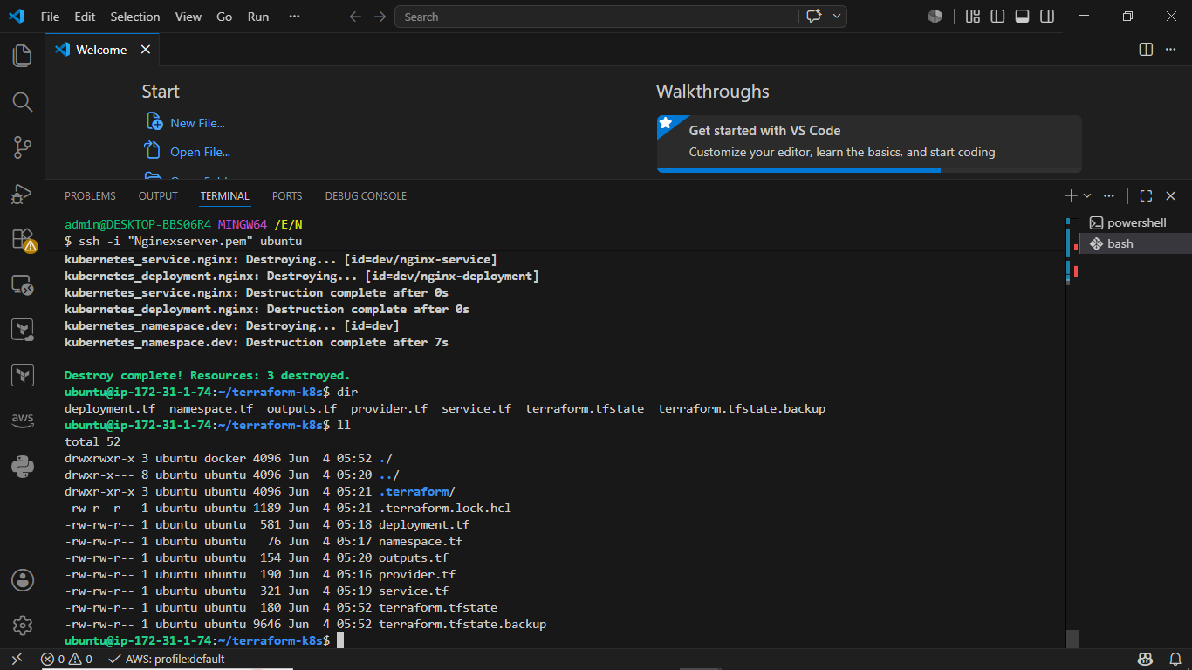

STEP 8: Configure Kubernetes Access
Verify kubeconfig: kubectl config view
Check location: ls ~/.kube/config
Expected: /home/ubuntu/.kube/config

STEP 9: Create Provider Configuration

provider.tf
terraform {
required_providers {
kubernetes = {
source = "hashicorp/kubernetes"
version = "~> 2.30"
}
}
}

provider "kubernetes" {
config_path = "~/.kube/config"
}

STEP 10: Create Namespace

namespace.tf
resource "kubernetes_namespace" "dev" {
metadata {
name = "dev"
}
}

STEP 11: Create Deployment

deployment.tf
resource "kubernetes_deployment" "nginx" {

metadata {
name = "nginx-deployment"
namespace = kubernetes_namespace.dev.metadata[0].name

labels = {
app = "nginx"
}
}

spec {

replicas = 2

selector {
match_labels = {
app = "nginx"
}
}

template {

metadata {
labels = {
app = "nginx"
}
}

spec {

container {

image = "nginx:latest"
name = "nginx"

port {
container_port = 80
}
}
}
}
}
}

STEP 12: Create Service

service.tf
resource "kubernetes_service" "nginx" {

metadata {
name = "nginx-service"
namespace = kubernetes_namespace.dev.metadata[0].name
}

spec {

selector = {
app = "nginx"
}

port {
port = 80
target_port = 80
node_port = 32767
}

type = "NodePort"
}
}

STEP 13: Outputs

outputs.tf
output "service_name" {
value = kubernetes_service.nginx.metadata[0].name
}

output "namespace" {
value = kubernetes_namespace.dev.metadata[0].name
}

STEP 14: Initialize Terraform
terraform init
Expected: Terraform has been successfully initialized

STEP 15: Validate Configuration
terraform validate
Expected:
Success!

STEP 16: Terraform Plan
terraform plan
Terraform will show:
+ kubernetes_namespace
+ kubernetes_deployment
+ kubernetes_service

STEP 17: Deploy Resources
terraform apply
Type: yes
Expected: Apply complete
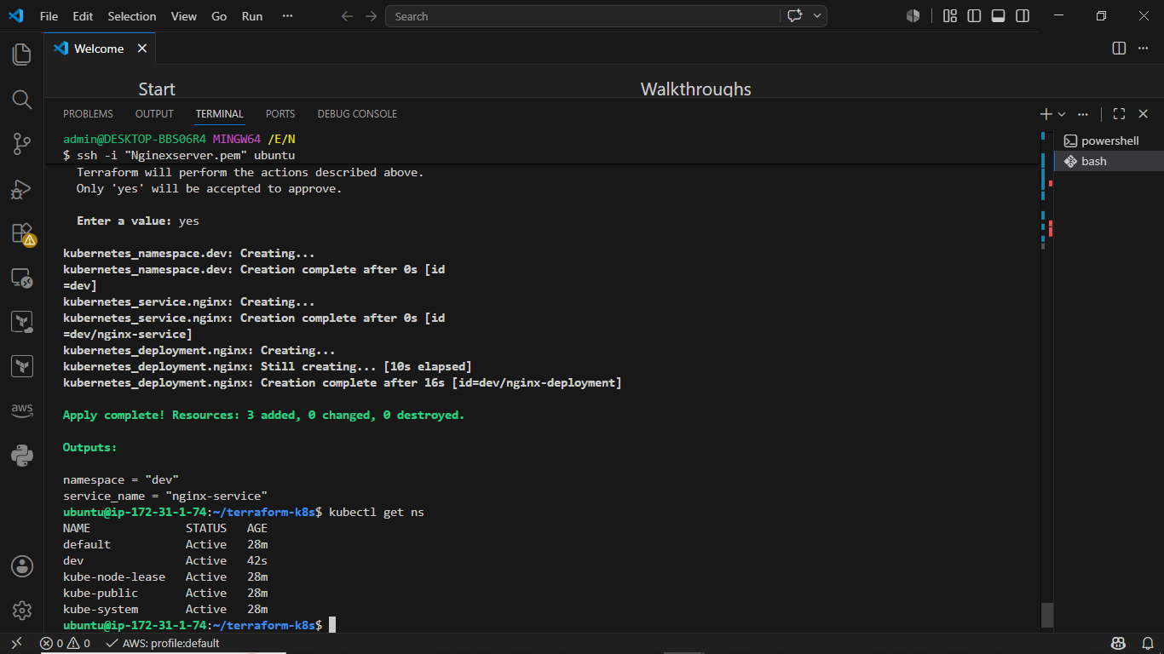

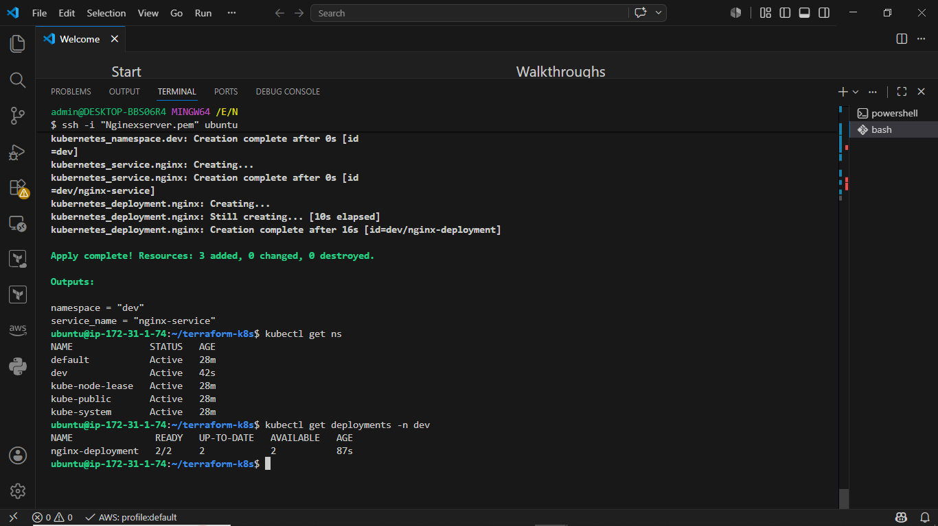

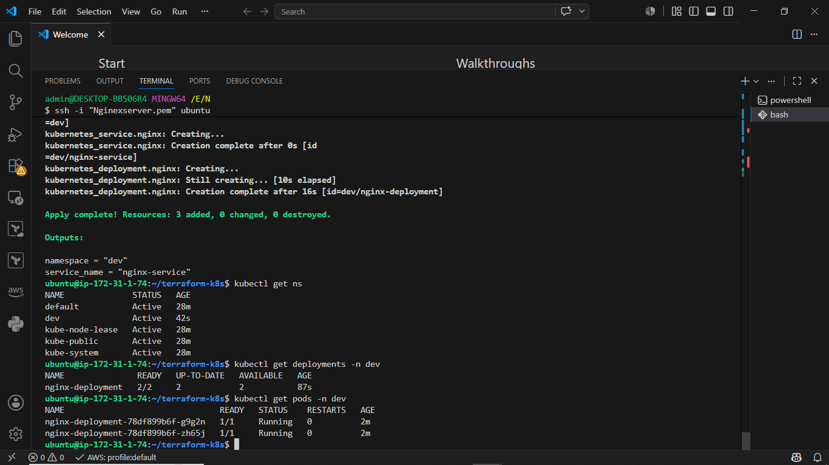

STEP 18: Verify Namespace
kubectl get ns
Expected:
NAME
default
dev
kube-system

STEP 19: Verify Deployment
kubectl get deployments -n dev
Expected:
NAME READY
nginx-deployment 2/2

STEP 20: Verify Pods
kubectl get pods -n dev
Expected:
NAME
nginx-deployment-xxxx
nginx-deployment-yyyy

STEP 21: Verify Service
kubectl get svc -n dev
Expected:
NAME TYPE
nginx-service NodePort

STEP 22: Get Minikube IP
minikube ip
Example:
192.168.49.2

STEP 23: Test Application
Inside EC2:
curl http://$(minikube ip):30080
Expected:
Welcome to nginx!

STEP 24: Access from Browser
Create tunnel:
kubectl port-forward service/nginx-service \
-n dev 8080:80
Open:
http://EC2-PUBLIC-IP:8080
You should see:
Welcome to nginx!

STEP 25: View Terraform State
terraform state list
Expected:
kubernetes_namespace.dev
kubernetes_deployment.nginx
kubernetes_service.nginx

STEP 26: Scale Application
Edit deployment:
replicas = 5
Apply:
terraform apply
Verify:
kubectl get pods -n dev
Expected:
5 Pods Running

STEP 27: Destroy Infrastructure
terraform destroy
Type:
yes
Verify:
kubectl get all -n dev
Nothing should remain.

terraform apply

kubectl get pods -n dev
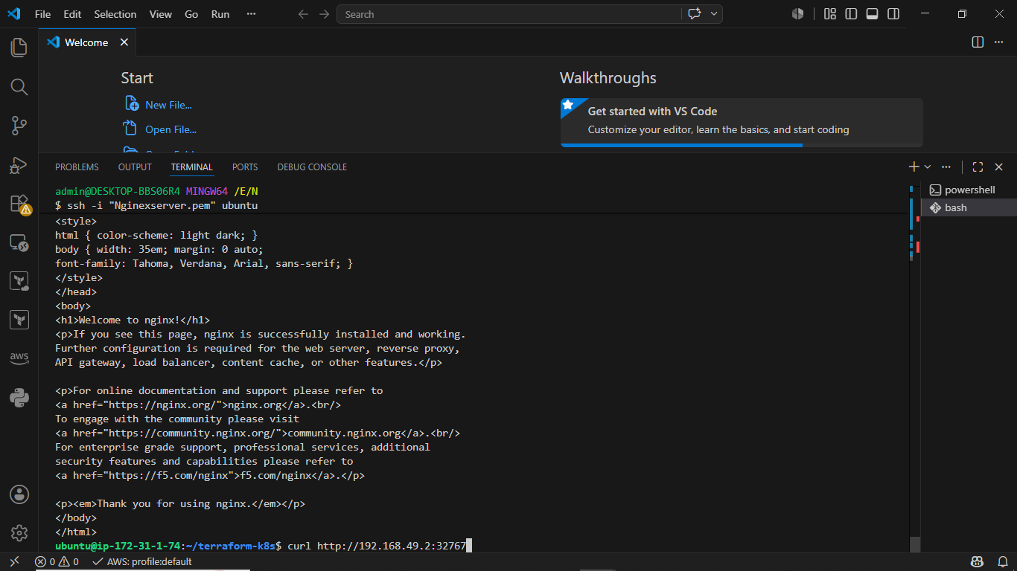

terraform destroy

